

Project Customer Retention

Submitted by:

ABHISHEK PAI

**ACKNOWLEDGMENT**

The Dataset and related information were provided by Flip Robo as part internship phase. This entire file package included a dataset with is column understanding to help with project analysis. Furthermore, guidance was provided by staff mentors in Flip Robo through doubt-solving sessions and tickets. Few code-related help and structure-related understanding was been taken from sources available on the internet.

**INTRODUCTION**

* Business Problem Framing

Customer satisfaction has emerged as one of the most important factors that guarantee the success of online store; it has been posited as a key stimulant of purchase, repurchase intentions and customer loyalty.

* Conceptual Background of the Domain Problem

A comprehensive review of the literature, theories and models have been carried out to propose the models for customer activation and customer retention. Five major factors that contributed to the success of an e-commerce store have been identified as: service quality, system quality, information quality, trust and net benefit. The research furthermore investigated the factors that influence the online customers repeat purchase intention. The combination of both utilitarian value and hedonistic values are needed to affect the repeat purchase intention (loyalty) positively. The data is collected from Indian online shoppers. Results indicate the e-retail success factors, which are very much critical for customer satisfaction.

* Review of Literature

There is not much research performed as the Data and related information was provided by the source itself, which was been taken into consideration based on the information given by Flip Robo.

* Motivation for the Problem Undertaken

The Project was assigned by flip Robo as part of the internship phase for better understanding the concept and getting the idea of the industry.

**Analytical Problem Framing**

* Mathematical/ Analytical Modeling of the Problem

After importing data various analyses were performed which had univariate, bivariate, and multivariate analyses.

Univariate analysis:Univariate analysis is the simplest form of analyzing data. It doesn't deal with causes or relationships and its major purpose is to describe; It takes data, summarizes that data, and finds patterns in the data.

Bivariate analysis:Bivariate analysis is one of the simplest forms of quantitative analysis. It involves the analysis of two variables, to determine the empirical relationship between them. Bivariate analysis can help test simple hypotheses of association.

Multivariate analysis: Multivariate statistics is a subdivision of statistics encompassing the simultaneous observation and analysis of more than one outcome variable. Multivariate statistics concerns understanding the different aims and backgrounds of each of the different forms of multivariate analysis, and how they relate to each other.

* Data Sources and their formats

After loading the data, the information of data was been checked and a five-row sample was been observed.

Later after performing analysis on the dataset, observation has been made

Data Pre-processing Done

The entire data was in form of excel and was objects.

* Hardware and Software Requirements and Tools Used

The system with a 16 core processor was been used,

The operating system was Windows 10,

Anaconda 3

Libraries: import NumPy as np

import pandas as pd

import seaborn as sns

matplotlib

matplotlib.pyplot as plt

pands profiling

.

* Visualizations

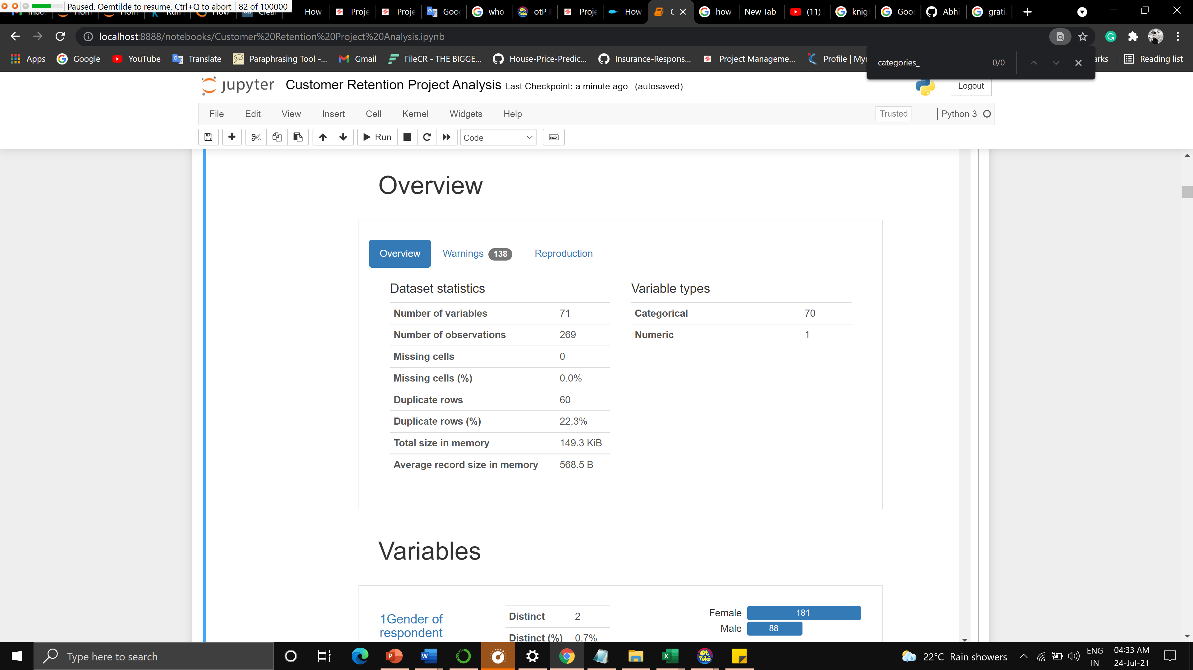

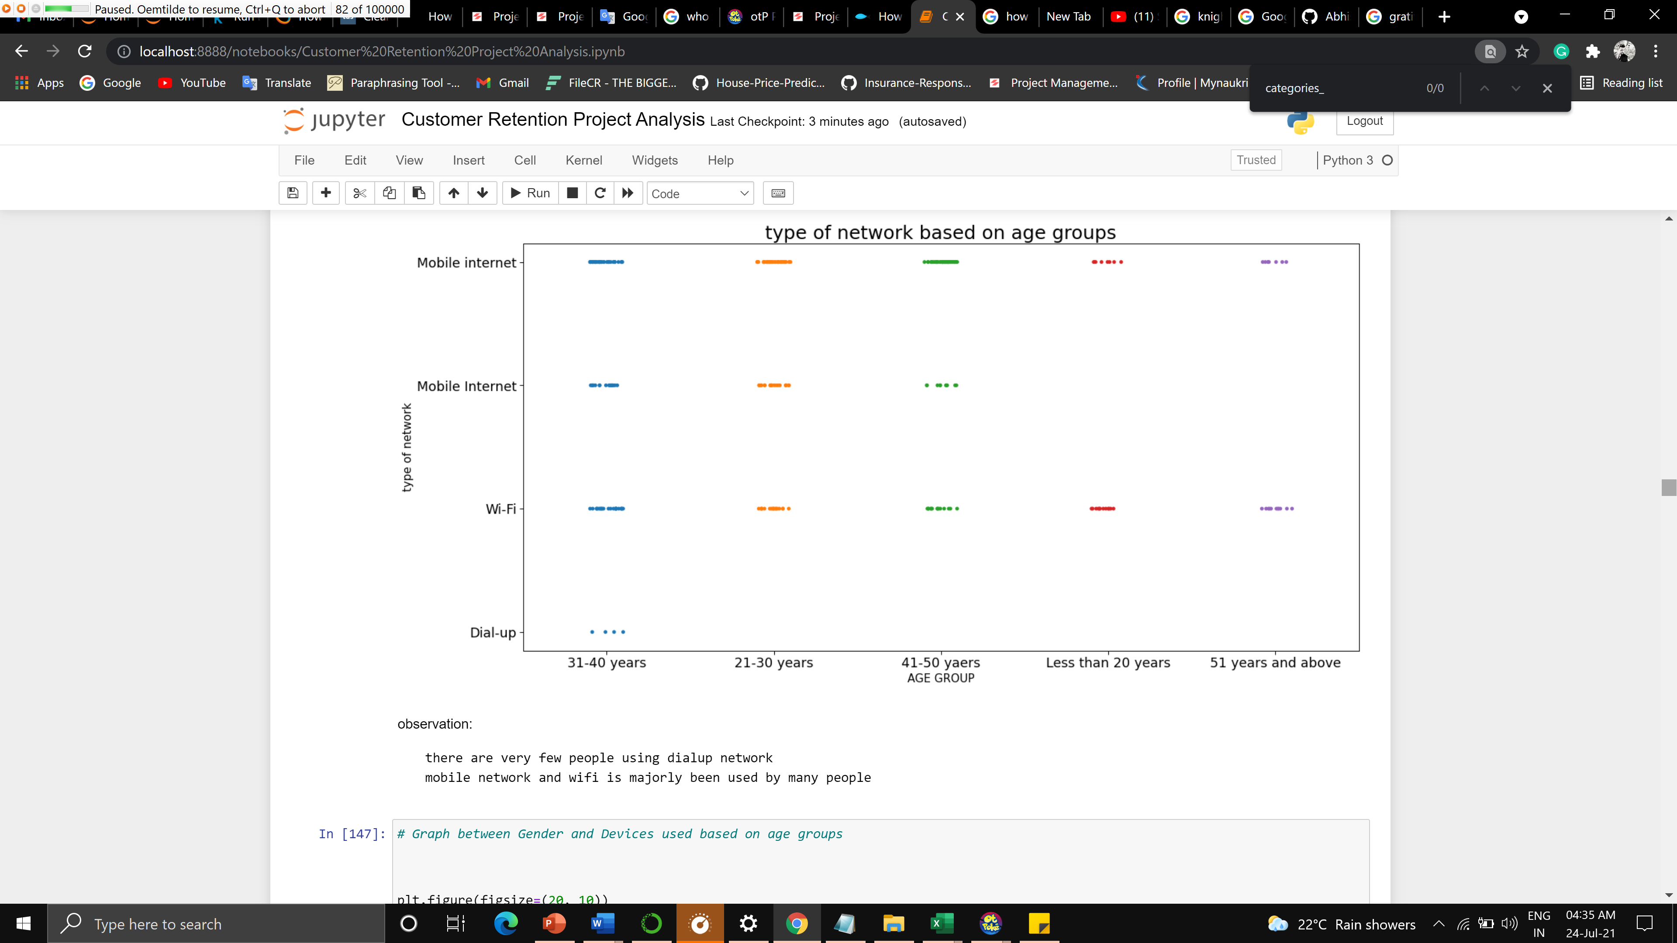



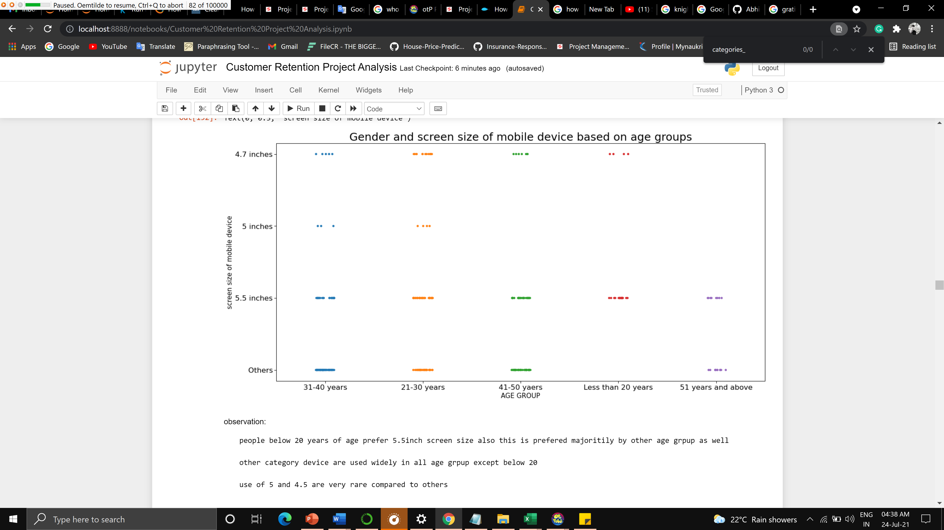

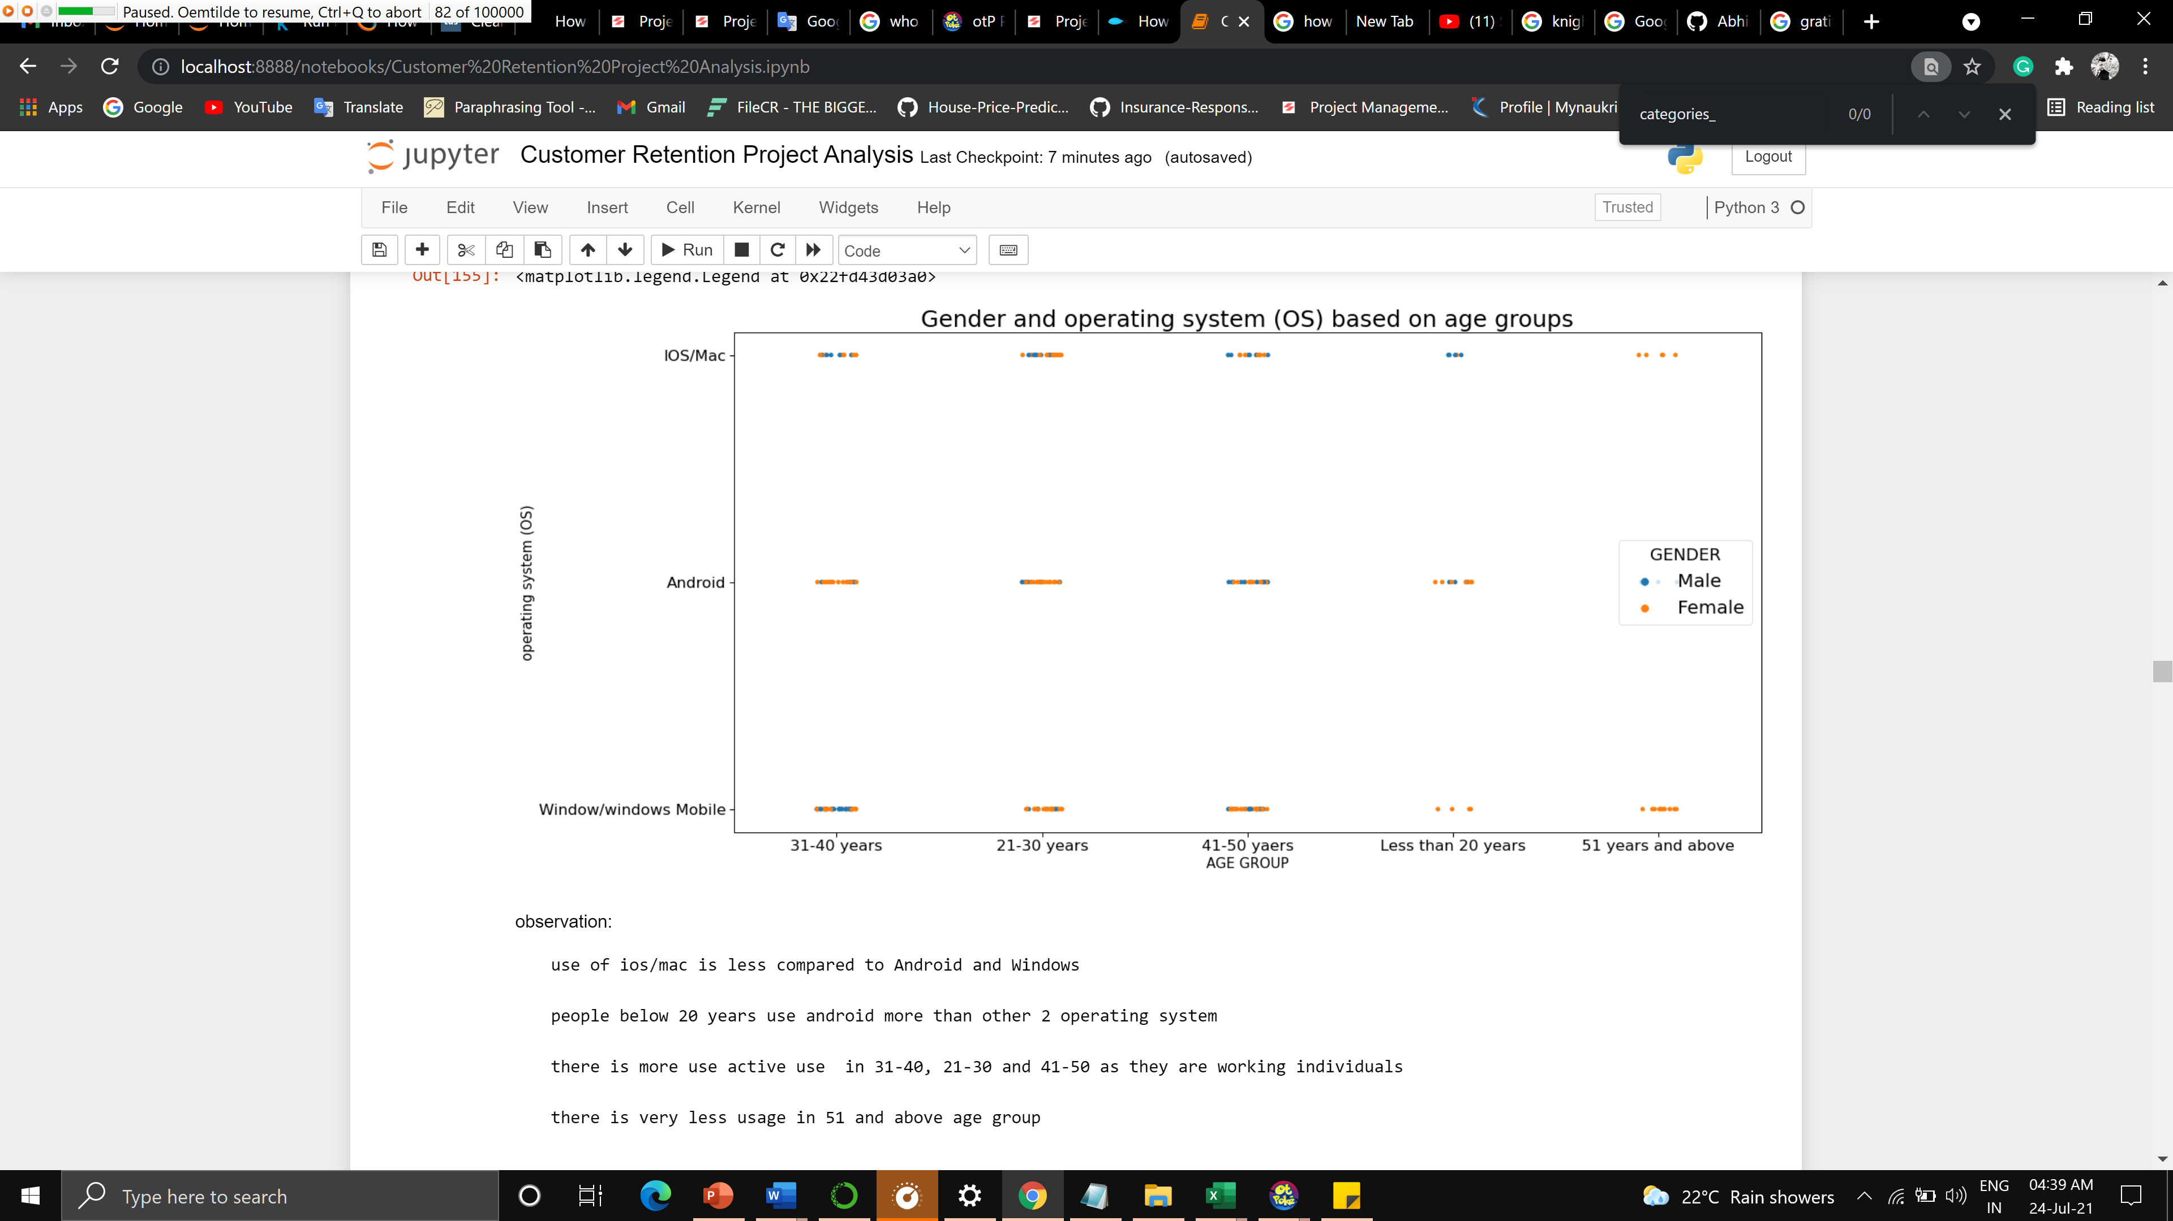

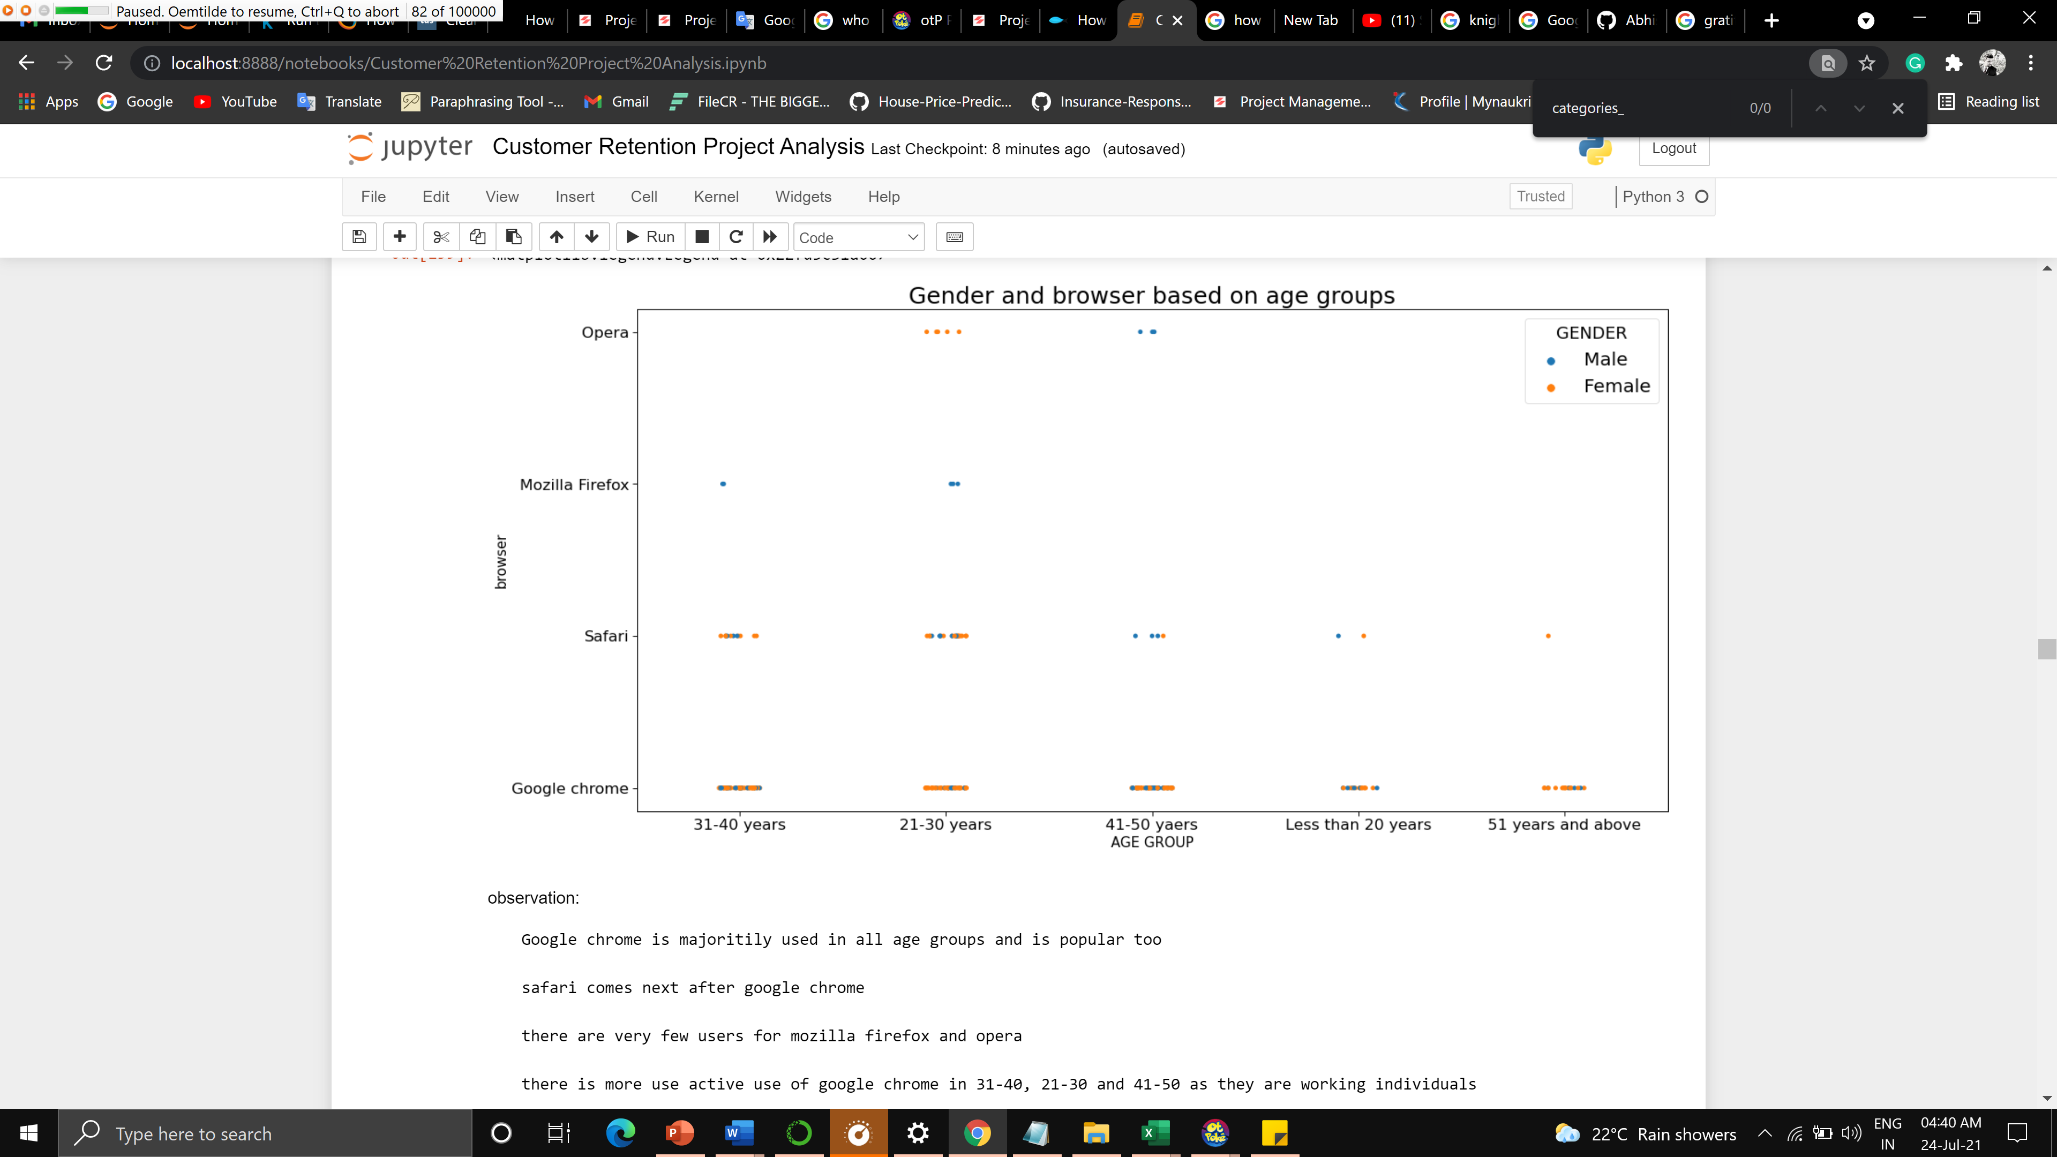

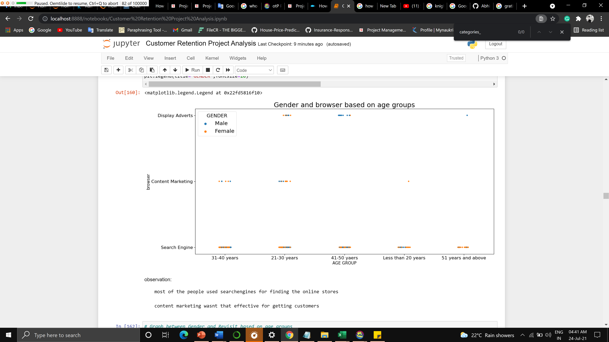

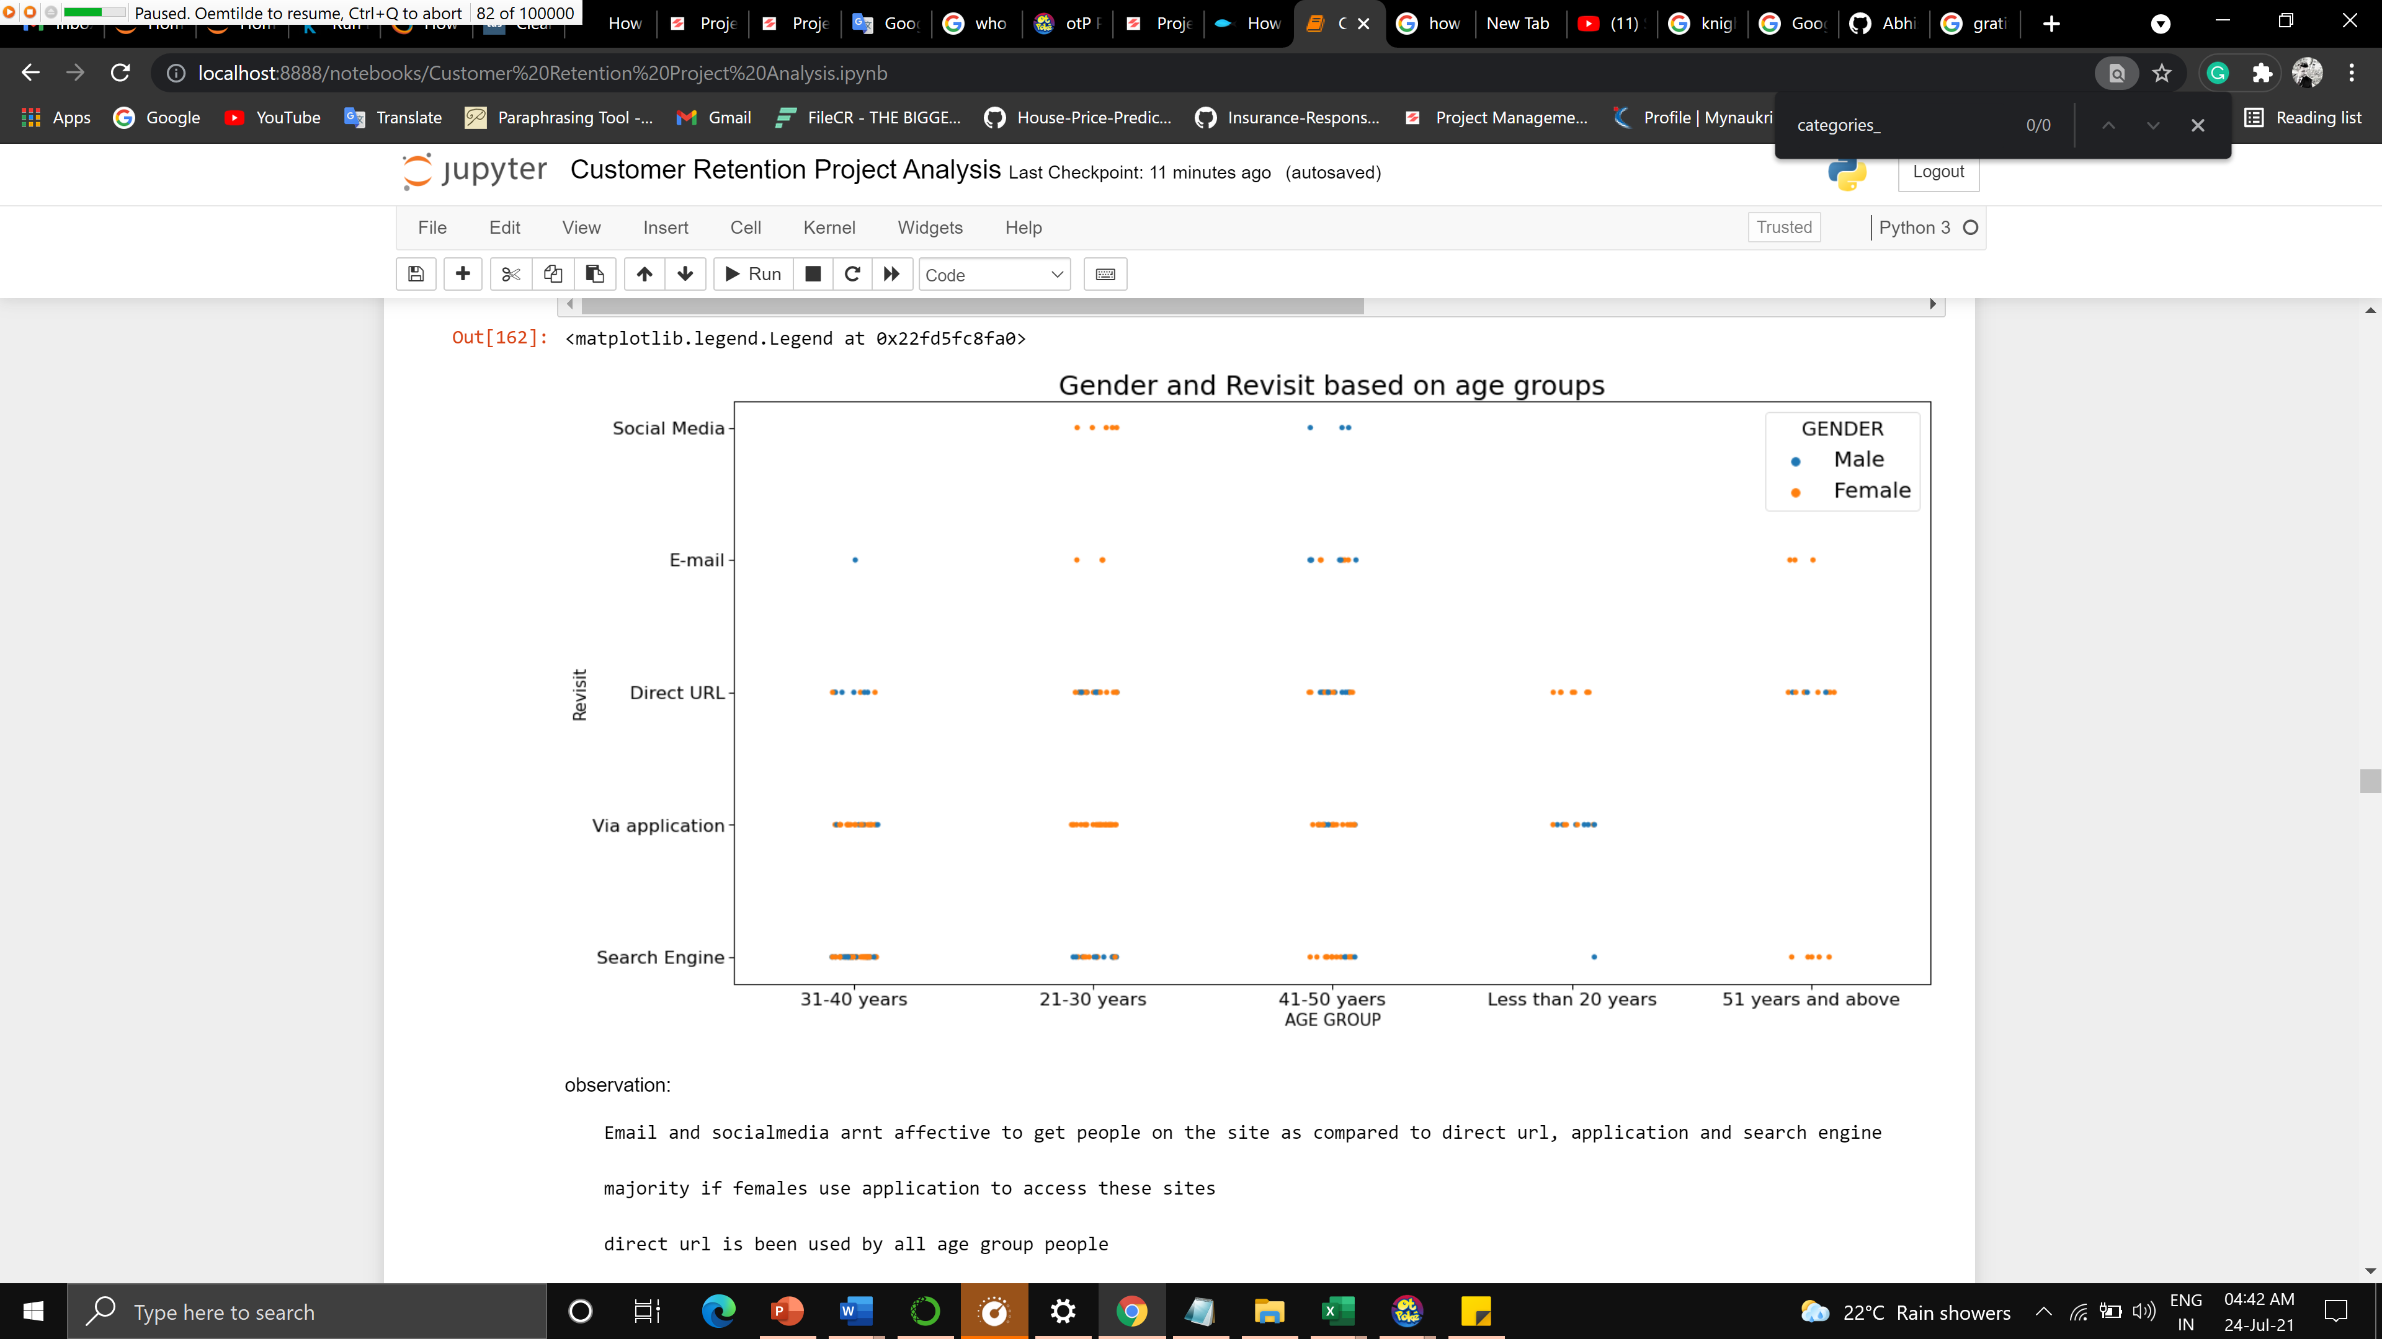

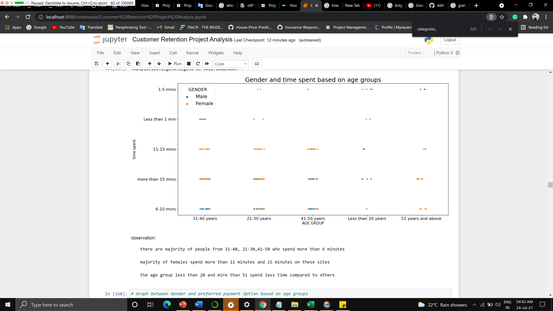

**CONCLUSION**

* Key Findings and Conclusions of the Study

More number of people are ordering less than 10 times in an year which includes males and females of all age groups

Very few people are ordering more than 42 times in a year the participated age group is 41-50 and less than 20 years

The age group of 31-40, 2-30 and 41-50 have been actively ordering.

A majority of females have been ordering from Bangalore, solan, gaziabad and Greater Noida

Majority of males have been ordering from Delhi , Noida, bulandshahr

There is an active participation of females majoritily form all age groups

The males from 31-40 and 41-50 have been more actively ordering

There are very few people using dialup network

Mobile network and wifi is majorly been used by many people

Tablet is rarely used by ant individual

Individuals less than 20 years of age use smartphones

Smartphones and laptops are used by the majority of people

Use of desktop is very less compared to laptop and smartphones

People below 20 years of age prefer 5.5inch screen size also this is prefered majority by another age group as well

Other category devices are used widely in all age groups except below 20

Use of 5 and 4.5 are very rare compared to others

Use of ios/mac is less compared to Android and Windows

People below 20 years use android more than the other 2 operating system

There is more use active use in 31-40, 21-30 and 41-50 as they are working individuals

There is very little usage in 51 and above age group

Google chrome is majorly used in all age groups and is popular too

Safari comes next after google chrome

There are very few users for Mozilla firefox and opera

There is more use active use of google chrome in 31-40, 21-30 and 41-50 as they are working individuals

Most of the people use search engines for finding the online stores

Content marketing wasn't that effective for getting customers

Email and social media aren't effective to get people on the site as compared to direct URL, application and search engine

The majority of females use an application to access these sites

Direct URL is been used by all age groups people

There are the majority of people from 31-40, 21-30,41-50 who spend more than 6 minutes

Majority of females spend more than 11 minutes and 15 minutes on these sites

The age group less than 20 and more than 51 spend less time compared to others

Majority of people prefer credit debit cards and cash on delivery

E-wallets are preferred by 31-40 and 41-50 compared to other age groups

The majority of females can be seen abandoning the bag in all age groups

Majority od people in all age groups sometimes abondon the bag

A change on price, promocode not applicable and better alternative are major reason for the people to abondon the bag

Majority of people expect websiste to be easy to read and understand, website with these ease are much used by these individuals

Many of people consider Information on similar product to the one highlighted is important for product comparison can be an inportant factor to gain peoples interest on the website and very few doesn't find any difference in it.

Complete information on listed seller and product being offered can be an important factor to gain peoples interest on the website and very few don't find any difference in it.

Many people prefer All relevant information on listed products must be stated clearly

Ease of navigation in the website is highly preferred by all individuals from different age groups except few

Loading and processing speed highly preferred by all individuals of different ages, especially people with high-end devices and network services or someone looking for some sale etc

User-friendly Interface of the website highly preferred by all individuals from different ages, not all people are good enough to understand complex UI design websites with these simple UI can get more customers

Majority of people prefer most commonly used payment methods as it is available to the major number of people

The website must keep the words and deliver on time majority of the people expect this and is an important factor for business growth too

​the Empathy (readiness to assist with queries) towards the customers is an important factor that attracts the majority of customers

Nowadays websites hold many critical data of customers from their card details to their mobile and address, majority of people consider privacy as an important factor for using a particular website

Many customers face issues, and they prefer to talk directly to the service desk by different means, in this case, a wide number of communication channels is what builds customers trust in the website

Some people love shopping to gain some discount or other benefits, for the majority of people this is a part that can grab their attention towards the website

Many people, the majority women get a feeling of enjoyment and satisfaction they feel happy when they buy stuff online

Majority of people prefer Shopping online in an convenient way and flexible way

The majority of people feel secure to shop online if there is a Return and replacement policy of the e-tailer

Many people like to gain access to loyalty programs is a benefit of shopping online it is like a cherry on the cake for them

Many people realistic information about the product this builds trust for the website

Better the website/application more and more customer perfer to use it

A wide variety of products helps gaining more customers to use the website

Many people consider online shopping as an adventure, for others its normal to shop but few people get a feeling of excitement which is a good sign for online retailers

Many people tend to post images of their shopping and consider it to raise their social status

Many people feel the Shopping on the website helps them fulfil certain roles which are a plus point for the online retailers

Pricing plays an important role for gaining customer, they should the money the spent is worth every penny.

* Limitations of this work and Scope for Future Work

There is a lot of scope, If more visualizartion will be used can give an better outcome